Application for Miami Children's Hospital
Pediatric Neurosurgery Fellowship Program
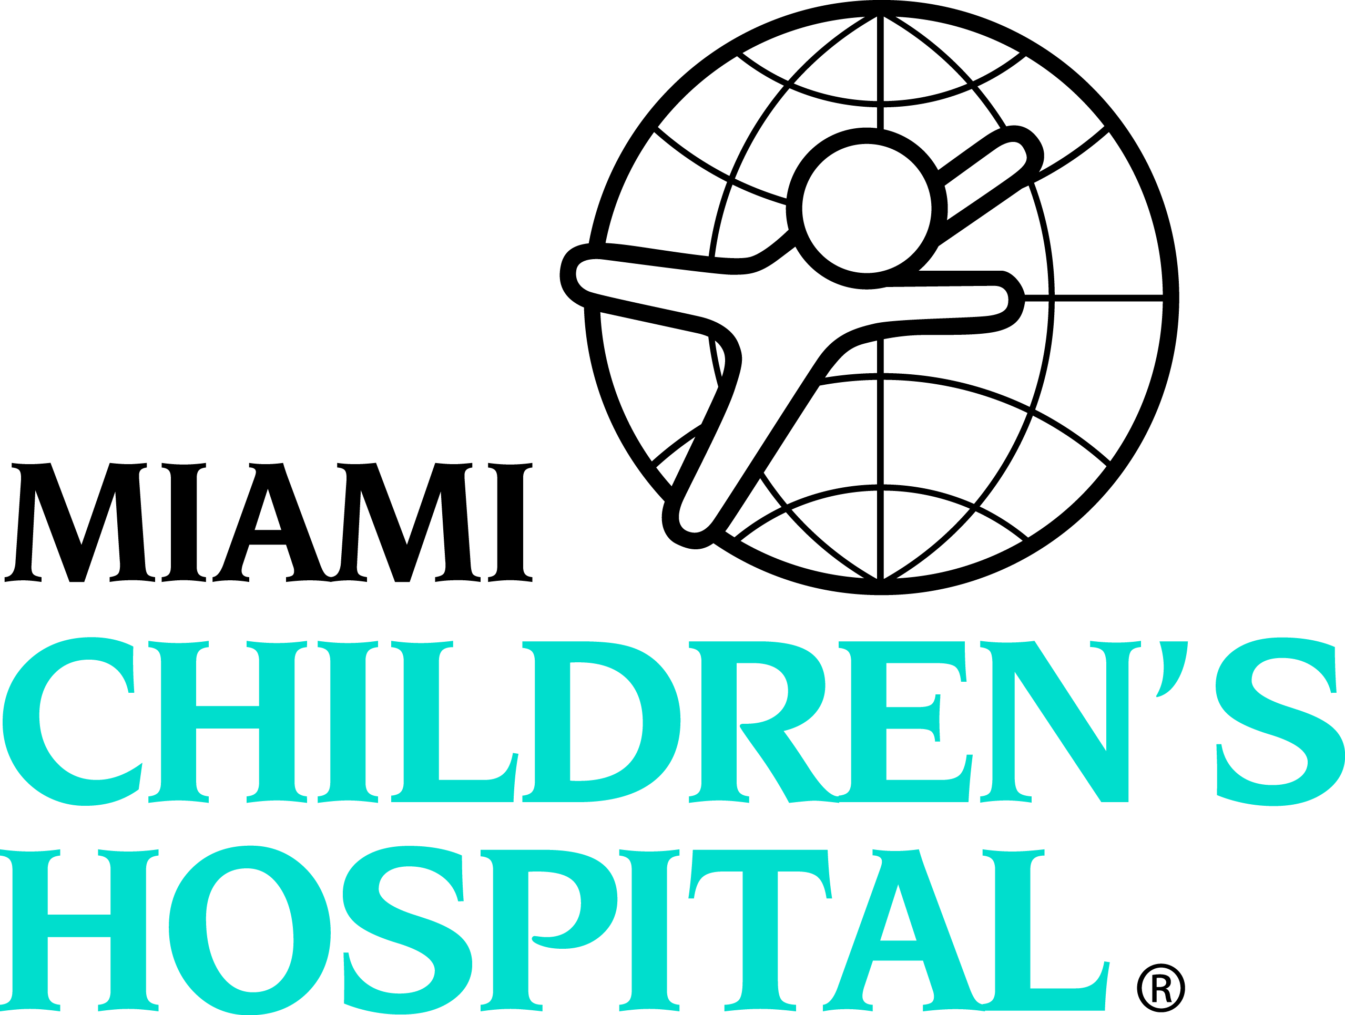

Application for Fellowship for Academic Year 20__ - 20__

PERSONAL DATA:
Name: | (type your name here)
Current Mailing Address:
Permanent Mailing Address:
Telephone Numbers: | Day:
 | Evening:
Email Address:
Social Security Number:
Date of Birth:
Place of Birth:
◻ U.S. ◻ Permanent ◻ J-1 ◻ Other

EDUCATION:
Degrees | School | Date Completed
Undergraduate:
Medical School:
Other:

RESIDENCY INFORMATION:
Title | Institution |  | Date Completed
USMLE: |  | Step 1:
(type in score) |  | Step 2: CSA:
 |  | Step 3:
Licensure: |  | State: Year:

Awards, Honors, and Memberships in Professional Societies:

Academic and Committee Memberships:

PROFESSIONAL REFERENCES: (List Three)

(1)
(2)
(3)

CHECKLIST FOR COMPLETION OF APPLICATION:

- Completed and signed application (including a 2x2 photo, optional)
- Curriculum Vitae (please include months and years)
- Personal Statement (one page)
- Medical School Diploma copy
- Residency Diploma copy (if applicable)
- USMLE score copies
- Three (3) letters of recommendation (one must be written by the Director of your Residency Program or Chair of your Department; must be in sealed envelopes)
- Medical School Transcripts (unofficial or copies is allowable)

_______________________________________ _____________________
Signature of Applicant Date

Please complete the application electronically. Print, sign, and email (preferred) or fax the application to:

Kari Bollerman
Email: kari.bollerman@mch.com
Fax: 305-663-8490

